“I Give you Back” by Joy Harjo

Joy Harjo is an internationally renowned performer and writer of the Muscogee (Creek) Nation. She is serving her second term as the 23rd Poet Laureate of the United States.
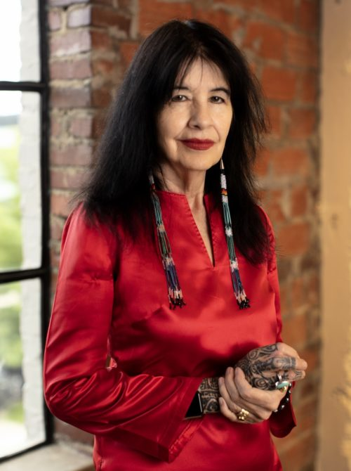
The author of nine books of poetry, including the highly acclaimed An American Sunrise, several plays and children's books, and two memoirs, Crazy Brave and Poet Warrior: A Call for Love and Justice, her many honors include the Ruth Lily Prize for Lifetime Achievement from the Poetry Foundation, the Academy of American Poets Wallace Stevens Award, two NEA fellowships, and a Guggenheim Fellowship. As a musician and performer, Harjo has produced six award-winning music albums including her newest, I Pray for My Enemies (Sunyata Records). She is Executive Editor of the anthology When the Light of the World was Subdued, Our Songs Came Through — A Norton Anthology of Native Nations Poetry and the editor of Living Nations, Living Words: An Anthology of First Peoples Poetry, the companion anthology to her signature Poet Laureate project. She is a chancellor of the Academy of American Poets, Board of Directors Chair of the Native Arts & Cultures Foundation, and holds a Tulsa Artist Fellowship. She lives in Tulsa, Oklahoma.

From https://www.joyharjo.com/

Before you read:

In your experience, what does it mean to live with fear?

What do you know about the suffering of indigenous people in South Dakota when white settlers came here?

To watch Harjo read this piece: https://www.youtube.com/watch?v=B0UxpEsi554
To find the poem: https://scholarblogs.emory.edu/eng190/files/2012/11/Joy-Harjo.fearpoem.pdf

- Why do you think she describes fear as both “beautiful and terrible” and both “my beloved and hated twin?”

- Underline what she tells readers about the way her ancestors were treated by white soldiers. How important are these specific images to the poem?

- What do you make of “I was born with eyes that can never close”?

- What do you make of “you have choked me but I gave you the leash” and the two other similar sentiments right after that line? Do you agree that we give fear its power?

- Highlight all the places where Harjo repeats herself in the poem. What is the effect of all this repetition? Select one place you like her use of repetition and answer: how might repetition enhance the meaning of the poem?

- What, to you, is the most powerful part of this poem? Your answer can be a line or something the poem made you think about.

Possible Prompt Ideas:
- Select an emotion that you want to release and write about releasing it.
- Describe fear as vividly as you can. Personify it or use metaphors to describe it in a way that you have never heard it described.
- Select an emotion that you want to invite in and write about why you have kept it at bay.
- Brainstorm a list of what emotions are “socially accepted” and what emotions people tend to keep to themselves. Compile little lists. Write about why you think we have these differences and consider how society would be different if it wasn’t this way.
- Write down every emotion you have felt in the last week and write about how we give some emotions more power than others.
- Select something you find both beautiful and terrible and write about it.
- Is there something in your life you consider in your blood or in your shadow? What is it? Write about it.

