“The Raincoat” by Ada Limón

Ada Limón, a current Guggenheim fellow, is the author of five poetry collections, including The Carrying, which won the National Book Critics Circle Award for Poetry. Her fourth book Bright Dead Things was named a finalist for the National Book Award, a finalist for the Kingsley Tufts Poetry Award, and a finalist for the National Book Critics Circle Award. She serves on the faculty of Queens University of Charlotte Low Residency M.F.A program and lives in Lexington, Kentucky.

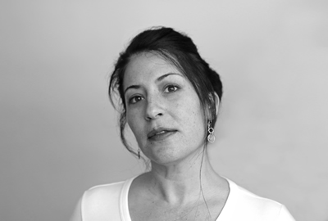

*Information taken from her website adalimon.com

Before you Read:

- Think about a caregiver of yours who has taken good care of you, which you likely take for granted. Write down three really specific things that person has done for you and what they may have sacrificed. It can be simple like the person has made me my favorite foods for dinner and they sacrificed time to do what they wanted, or the person has bought me new clothes and sacrificed by earning money and working hard and spending money on me.

Caregiver: __________________________________

Things the caregiver has done for me | Things they have sacrificed
1.

2.

3.

Vocab: Look up definitions to unfettered ________________________________________________
maudlin____________________________________________________________________

Now read the following poem closely: https://poets.org/poem/raincoat

Answer the following questions about the poem:

- What specifically did Limón’s mom (parents) do for her?

- What do you think this cost them (both time-wise and financially)?

- Why is it important to Limón to point out that her mom had her sing songs?

- Notice that she still sings songs on her way home from the doctor. It seems that her mom taught her a coping mechanism that she still uses. How have you learned to cope with something difficult from a caregiver?

- Do you think Limón actually saw a mom putting her raincoat on her daughter? Does it matter if Limón saw this on that very day? (I ask this to show you the creative liberty you can take with poetry).

- What does she mean that she has been under her mother’s raincoat?

- What does you think it means that she never got wet?

Possible poem writing prompts:

- Write about something really specific a caregiver has done for you and comment a bit on how little you noticed it. Notice how specific Limón is in her poem.
- Consider a metaphor like a raincoat/getting wet and write about the way a caregiver has taken care of you, introducing the metaphor at the beginning or end of the poem.
- Write about a coping mechanism you have learned and how you learned it and when you still use it.
- Write about an actual raincoat and how it has protected you from the rain, then connect that to something else briefly in the poem. For example, switch up this poem so that it’s mostly about a raincoat and then there are a few lines showing the raincoat is actually a metaphor for something else, maybe even something abstract like faith, hope, love, etc.

